Yellow Curry (Island Style)
A coconut curry with island swagger—fragrant, creamy, and flexible enough for fish, chicken, or shrimp.
Prep time: 10 minutes Cook time: 20 minutes Yield: 4 servings
This one sits somewhere between Caribbean comfort and weeknight curry: onion, garlic, ginger, coconut milk, and yellow curry cooked until the whole pan smells like you meant to do something good tonight. Use fish if you want it lighter, chicken if you want it heartier, and finish it with lime so the richness stays awake.

Ingredients
- 1 lb. boneless chicken thighs, firm white fish, or peeled shrimp
- 1 tbsp neutral oil or coconut oil
- 1 medium onion, diced
- 2 cloves garlic, minced
- 1 tbsp fresh ginger, grated or minced
- 1–2 tbsp yellow curry powder, to taste
- 1 tsp ground turmeric (optional, for deeper color)
- 1 (13.5-oz) can full-fat coconut milk
- ½ cup chicken stock, water, or seafood stock
- 1 medium potato, peeled and cut into small cubes
- 1 small carrot, thinly sliced
- 1 bell pepper, sliced
- 1 tsp brown sugar or honey
- 1 tsp soy sauce or fish sauce
- Salt and black pepper, to taste
- Juice of ½ to 1 lime
- Optional: 1 hot pepper, a pinch of red pepper flakes, chopped cilantro, or scallions for finishing
- Cooked rice, for serving

Directions
- Heat the oil in a deep skillet or saucepan over medium heat. Add the onion and cook 3–4 minutes until softened. Stir in garlic and ginger and cook 30 seconds more.

- Add curry powder (and turmeric, if using) and stir for 30–60 seconds to bloom the spices. Don’t let the garlic scorch.
- Pour in the coconut milk and stock, whisking to dissolve the spices. Add the potato and carrot, then bring to a gentle simmer.
- Cook 8–10 minutes, until the potatoes are beginning to soften. Add the bell pepper.
- If using chicken, add it now and simmer gently for 8–10 minutes more, until cooked through and tender. If using fish, wait until the potatoes are almost fully tender, then add the fish and simmer 4–6 minutes, just until it flakes easily. If using shrimp, add them in the last 3–4 minutes, just until pink and firm.
- Season with brown sugar, soy sauce or fish sauce, salt, and black pepper. Taste, then brighten with lime juice.
- If you want heat, add sliced hot pepper or red pepper flakes near the end so the curry keeps its fresh edge.
- Serve hot over rice and finish with cilantro or scallions if you like.

Chef’s Notes
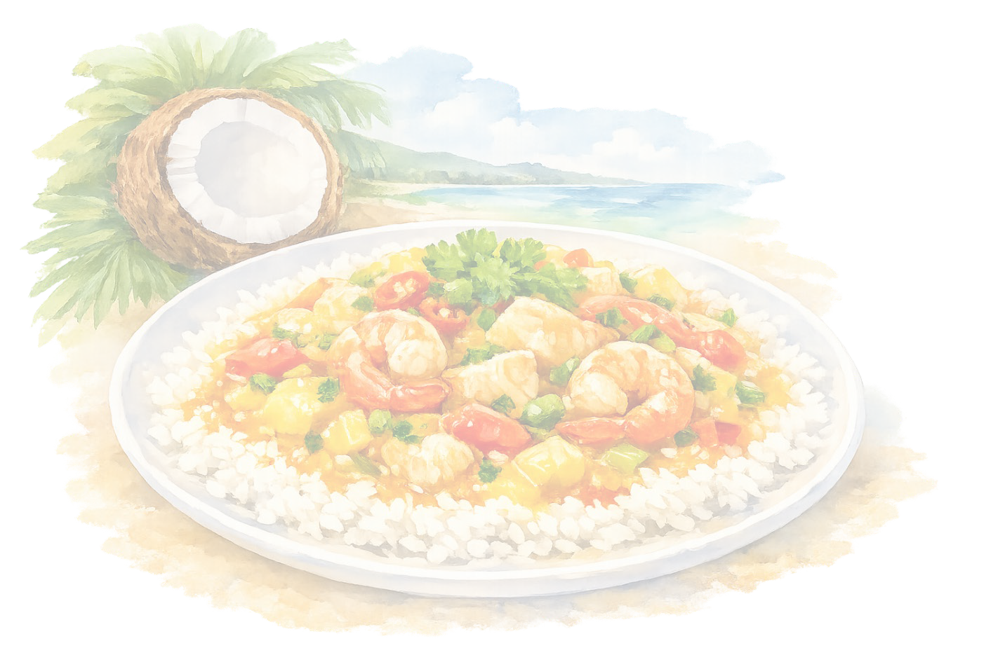
The big trick here is balance: curry powder for warmth, coconut milk for body, and lime at the end so it doesn’t go sleepy. Potatoes make it feel more like a meal, but you can swap in sweet potatoes, peas, green beans, or chickpeas depending on what’s around. If you want a more Caribbean lane, add thyme and a Scotch bonnet; if you want it milder, keep the pepper out and let the ginger do the work. See also: Jamaica Jerk Sauce; Black Beans & Rice; Spiny Lobster Tails — Twist on Tradition.

