No League for Young Me.n
Baseball was my first obsession. When I was young, I was small, clumsy, and couldn’t hit worth a damn, so I spent a lot of time in Little League, sitting on the bench. But I loved baseball.
When I got tired of chasing bugs in right field, I volunteered to catch. That got me more playing time, but it also got me beaten to hell.
My left hand was permanently bruised. Mom stuffed cotton balls in my catcher’s mitt. I fell forward to block balls in the dirt. Got hit in the helmet by bats. Sometimes I just got hit by the pitch because I couldn’t catch it. I wasn’t a good catcher—I was just the only one dumb enough to volunteer. And I wore those bruises like badges.
By the time we moved to the Sunshine state, I’d grown some and could finally hit.
Newark, Ohio, is home to the Babe Ruth World Series, and we got to play at the complex during my time in that league—four diamonds facing each other so tight that a deep home run could be caught in another game. Still a home run. No out. I loved that place!
When we got to Florida, I was excited to try American Legion ball. We’d heard stories about Florida kids—six feet tall, throwing 90 mph, crushing wooden bats, playing year-round. Turns out the rumors were mostly true.
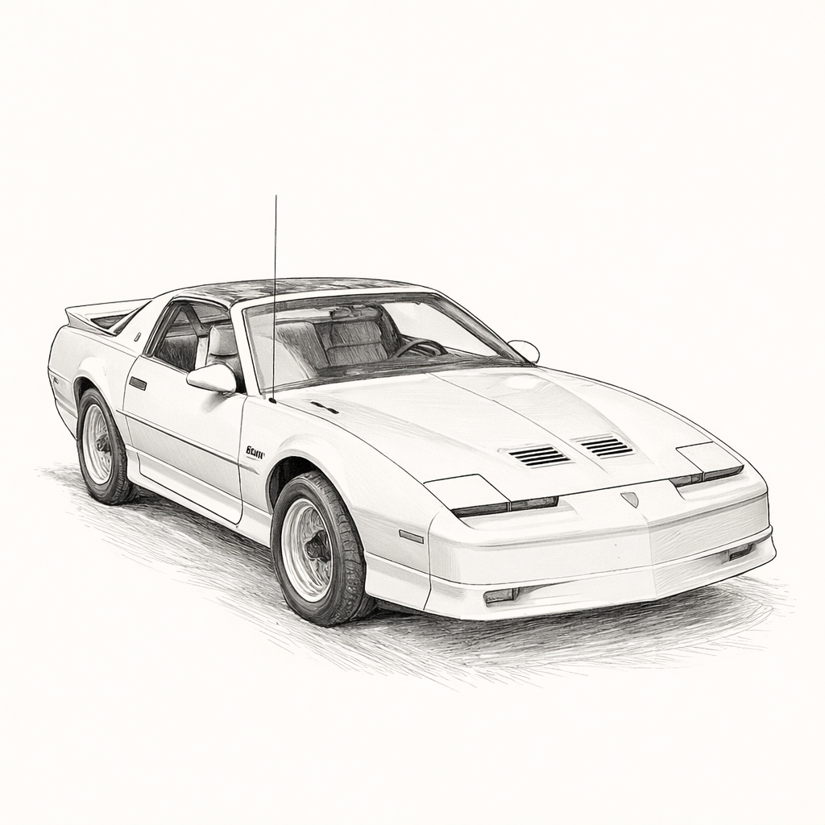
The first game with the new team was scheduled in Ft Myers, so my parents dropped me off so I could ride with my teammates.
The kids were driving their own cars, so I bummed a ride. The kid driving was one of the older players and had a new Pontiac Firebird. That thing was stupid fast.
He floored it on I-75, and I swear we hit 150 before he backed off. We did most of the 30-mile trip at 120 and arrived 15 minutes before anyone else. I was terrified and exhilarated. Once my knees stopped shaking, I warmed up with the rest of the team, grateful to be alive.
We were losing in the late innings, and the coach cleared the bench (just me!).
Right field—the usual hiding spot for kids like me.

